**Assignment 8**

1. Write a program in C++ to print welcome text on a separate line.

Code:

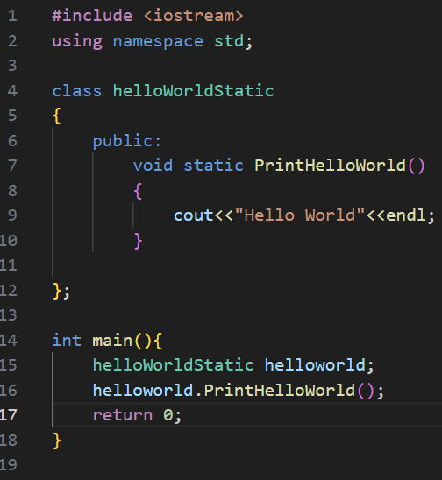

Output:

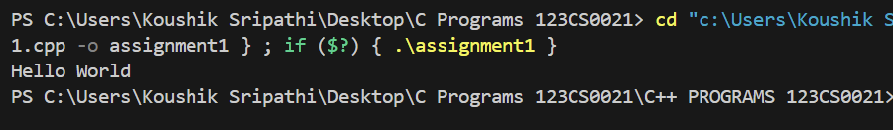

1. Write a program in C++ to print the sum of two numbers.

Code:

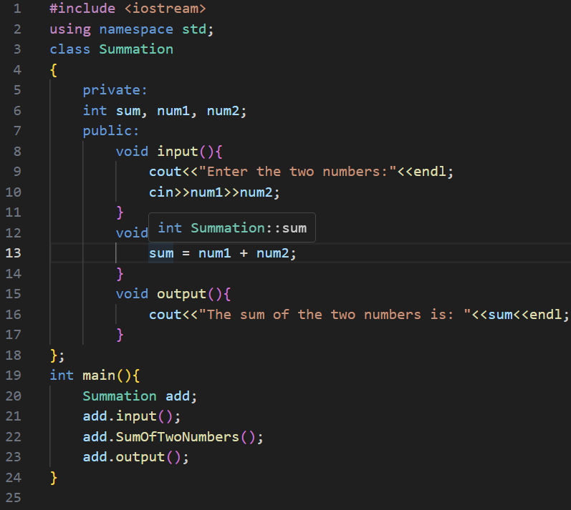

Output:

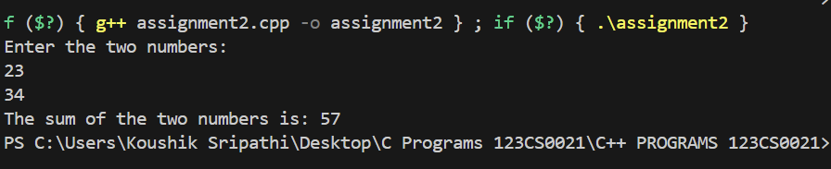

1. Write a C++ program that swaps two numbers.

Code:

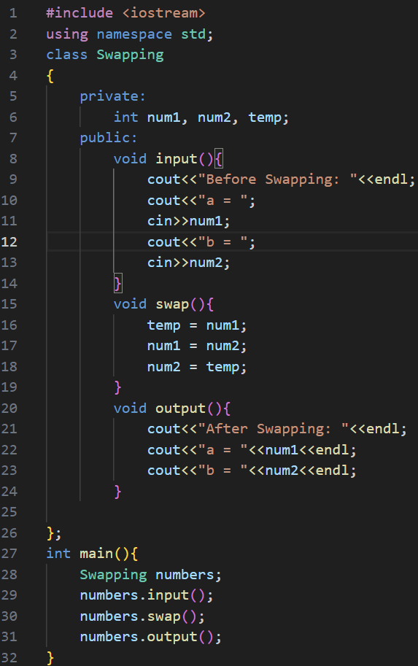

Output:

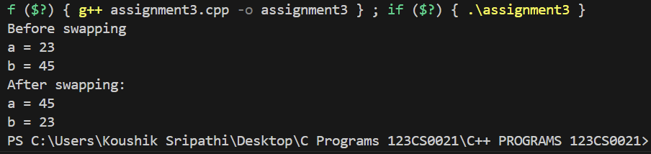

1. Write a C++ program that calculates the volume of a cube.

Code:

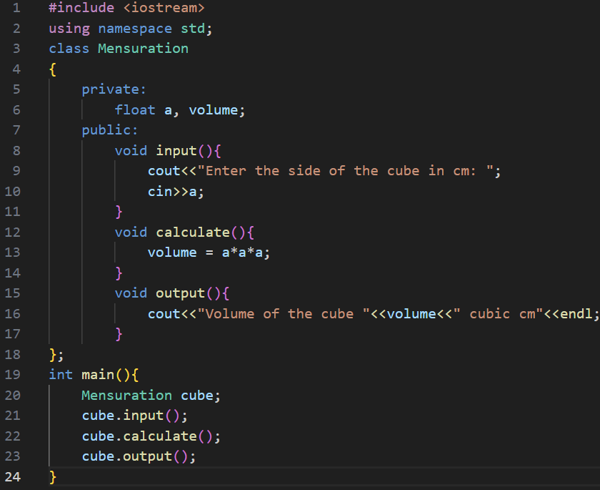

Output:

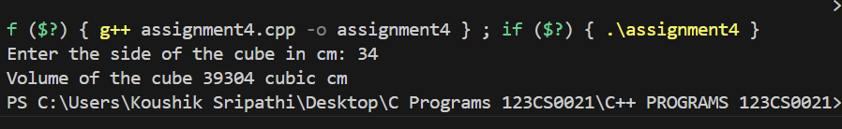

1. Write a C++ program to compute the total and average of four numbers.

Code:

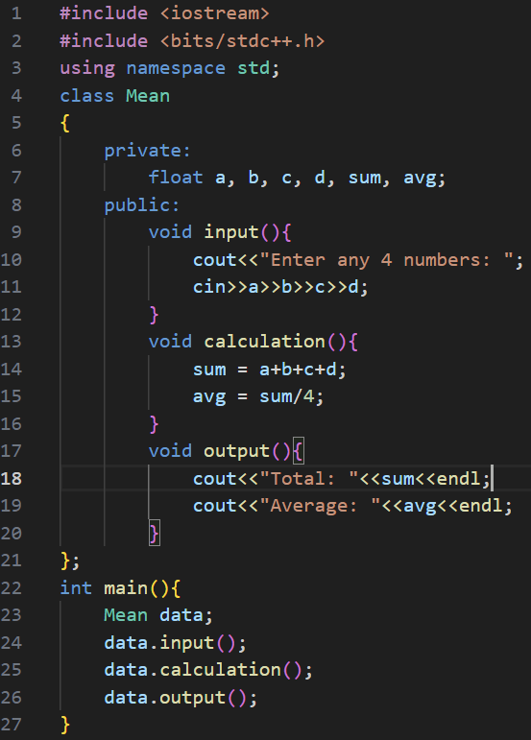

Output:

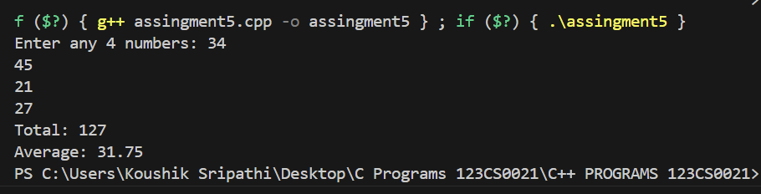

1. Write a C++ program that takes a number as input and prints its multiplication table up to 10

Code:

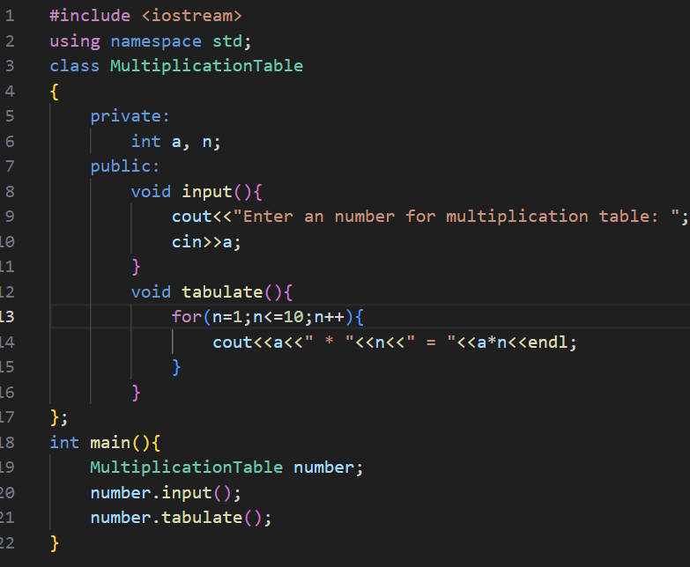

Output:

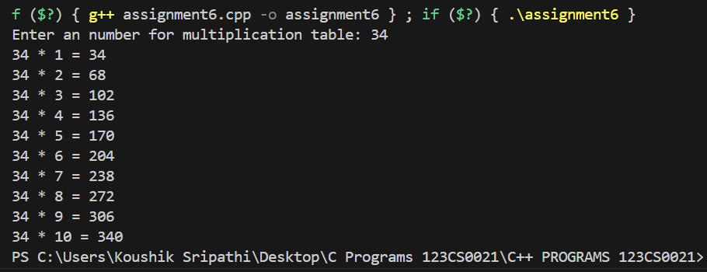

1. Write a C++ program that accepts the user's first and last name and prints them in reverse order with a space between them.

Code:

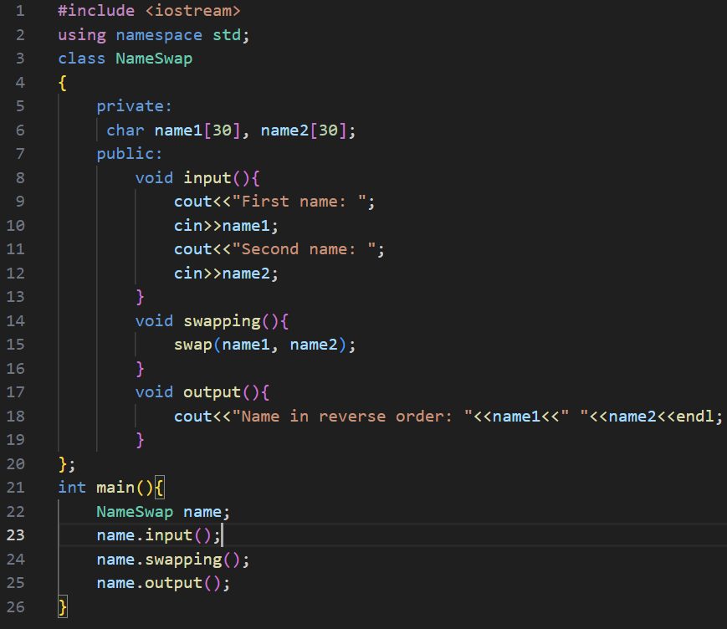

Output:

